Proposed Minutes for September 14, 2015 OPA General Meeting
7:00 – 9:00 PM Joslyn Park
633 Kensington Road, Santa Monica CA 90405

BOARD MEMBERS PRESENT:
Judy Abdo, David Auch, Mark Gorman, Sadat Huq, Kate Kennedy, Jim Lawson, Mary Marlow, Evan Meyer, Marc Morgenstern, Mike Salazar, Jodi Summers, Roger Swanson, Patty Godon-Tann, Dave Tann

NOTICED BOARD MEMBER ABSENCES: Andrew Gledhill

- Introduction to OPA (Jim Lawson – 1 minute)

- Membership Announcement (Sadat Huq – 3 minutes)

- Community Comments
- Dave T.: Heal the Bay Beach Clean-up 9am-12, Saturday 9/19
- Judy: Pier visioning workshop, Mon. 9/21 6:30pm
- Roger: Planning Commission meeting re: Lincoln Boulevard Linc
  - Traffic issues outstanding, goes the City Council
- Roger: Pico transient issues Meeting
- Jim: California Incline Pedestrian Bridge meeting Oct. 5 Ken Edwards 5pm-7:30pm
- Mike: Food trucks Tuesday at Victorian, Beach Blanket dragsters

- Actions Taken Since Last Board Meeting
- Patti- Joslyn Park Permit revised to 6:30pm-9:30 in the future

- Southern California Metroplex Letter - Board Action Item (Mike Salazar - 10 minutes)
- Mike: FAA: Make air traffic more efficient and safer with 3 mile separation via turn over Ocean Park (260 heading)
- But adds noise over OP without public stakeholder input
- FAA didn’t look at interim solutions or mitigations
- Roger: What’s city position on extended runway?
- Mike: FAA should have looked at western parcel going away and shortened runway

MOTION: To approve and send position letter to FAA re: Metroplex (attached below) drafted by Mike
MADE BY: JODI
SECONDED BY: ROGER
PASSED UNANIMOUSLY

- OPA Marketing - Resident Membership and Business Membership Discussion (Marc Morgenstern - 15 minutes)
- Marc: Explains status of proposed promotion with Main St. restaurants to offer discounts/specials for card carrying OPA members
- General discussion of advisability of approaching Lincoln Blvd. merchants with similar program
- Patti—Lincoln a hard sell, pilot Main St. first
- Kate—Why not approach some Lincoln merchants and test waters
- Mary—Extend to Cha Cha Chicken, Il Tecate and others

- Evan—To simplify and save costs, email pdf of membership card to member rather than mailing physical card; member can print out or keep on phone
- Marc agreed to keep Board updated on discussions with Main St. merchants towards project pilot this fall
- General discussion of expanding memberships for businesses rather than residents
- Sadat—we already offer $50 membership to businesses: only two so far
- Evan—offer discounted or free membership to businesses as incentive to participate in promotional program
- Kate—allow one year free business membership to attract
- Jodi—We should serve all members of community
- Julie (audience member)—concerned of conflict of interest with business members
- Mike—Businesses can participate through sponsorships

- OPA Online Strategy (Evan Meyer and Jodi Summers - 10 minutes)
- Jodi—We must answer the question: Why join OPA?
- Patti—Borderline experience—viable activities (Parade etc.) drive membership
  - They put us in position to interface with people, i.e. Pancake breakfast
- Evan—Lot more residents than businesses, so greater potential with people
  - Invite Santa Monica friends to join our Facebook page
  - We should write down goals: Sign up 5% or 10% of community?
- Mike—People join us for our advocacy
- Evan—Should we add “Voice Your Concerns” to every agenda
  - Remember to serve our community mission
- Kate—We need to get the word out about OPA activities outside of this room

- Powerbox Decoration Strategy (Evan Meyer and Jodi Summers 10- minutes)
- Jodi—Blessing of Cultural Affairs Director to paint boxes
  - What outreach do we make to community? SMC? HS?
- Evan—Wide range of opportunity
  - Focus on neglected boxes
- Judy—great idea, community statement
- David A—need to get functional behind idea
  - Can neighbors have input or veto power?
- Mike—start small, can change, commercial sites first
- Mary—How funded?
- Evan—Beautify Earth funds
- Marc—Let’s say yes, rare opportunity from Jessica, seize opportunity
- Mike—want to make sure no financial conflict

MOTION: OPA enthusiastically asks the committee to develop a work plan with Jessica Cusick, including next steps for gradual implementation and a process to determine the designs and address possible neighbor concerns.
MADE BY: JUDY
SECONDED BY: MIKE
MOTION PASSES: 10 Yes 1 No 3 Abstain

- Establishment of Board Elections Committee for 2016 Elections (Patty Godon-Tann – 10 minutes)
- Patti—1 terming out (David A.); Jim, Marc, Patti, Judy, Mark G, Mike S, David T. up for reelection
  - Nominating committee includes five OPA members, no active candidates, at least 1 non-board member, at least 2 board members,
  - Non-Board members must count ballots
  - Also, must present revised ByLaws for membership approval
  - Each candidate submits statement within format
  - Oct. 20th statements due and confirmation of intent to run or not
- Mary—Hold election in Nov. to invite City Manager; Mary will confirm availability
- Jessica agrees to lead Nominating Committee
- David A. agrees to join Committee

- Decision on Board Size for 2016 Board (Jim Lawson – 15 minutes)
- Jim—Had talked about 13 members, from 15
  - Agreed to table until next month
- Report from Neighborhood Council Meeting (Mary Marlow – 5 minutes)
- Rick Cole discussed doing away with Development agreements
  - 40 DA’s currently in pipeline
- Subcommittee on Downtown Specific Plan will come back with recommendations
- Approval of Minutes from August 10th Meeting (Marc Morgenstern – 2 minutes)

MOTION TO APPROVE AUGUST MINUTES
MADE BY: JIM
SECONDED BY: MARK G.
PASSED BY ACCLAIMATION

- Treasurer’s Report (Patty Godon-Tann – 5 minutes)
- General account: $600 member fees from parade, $2,200 total
- Keeping Wild Apricot for $1080 including 10% discount
- Bought 1,000 OPA non-lickable envelopes
- $132 for PO box

- Committee Reports:

- Main Street Committee (Marc Morgenstern – 5 minutes) (see above)
- Tree Committee (Jim on behalf of Andrew Gledhill – 5 minutes)
  - Watering guidelines
  - New tree in Hotchkiss Park
- Santa Monica Airport (Mike Salazar – 5 minutes) (see above)
- Beautify Earth (Evan Meyer – 5 minutes) (see above)
- Membership (Sadat Huq – 5 minutes) •
  - 239 current members, 1031 emails sent
- Communications (Jodi Summers – 5 minutes) • (see above)
- General Plan (Mary Marlow – 5 minutes) • (see above)
- Lincoln Boulevard Task Force (Roger Swanson – 5 minutes) •
  - New trees
  - Reduction in flags and A frames
- Ocean Park Zoning (Judy Abdo – 5 minutes) (see above)
  - Met about passed Zoning Ordinance, Julie Dad to read

Next meeting is on Monday October 12, 2015 at 7:00PM at Joslyn Park.
Refreshments September: Mark Gorman

OPA Board Voting Roster

Item: FAA Metroplex
Motion: To approve and send position letter to FAA re: Metroplex (attached below) drafted by Mike

Made by: Jodi Seconded by: Roger

Date: 9/14/15

Board Member | Y | N | Abstain |  | Board Member | Y | N | Abstain
Judy Abdo | X |  |  |  | Mary Marlow | X
David Auch | X |  |  |  | Evan Meyer | X
Andrew Gledhill |  |  |  |  | Marc Morgenstern | X
Patty Godon-Tann | X |  |  |  | Mike Salazar | X
Mark Gorman | X |  |  |  | Jodi Summers | X
Sadat Huq | X |  |  |  | Roger Swanson | X
Kate Kennedy | X |  |  |  | David Tann | X
Jim Lawson | X

Totals: Yes 14 No 0 Abstain Absent 1

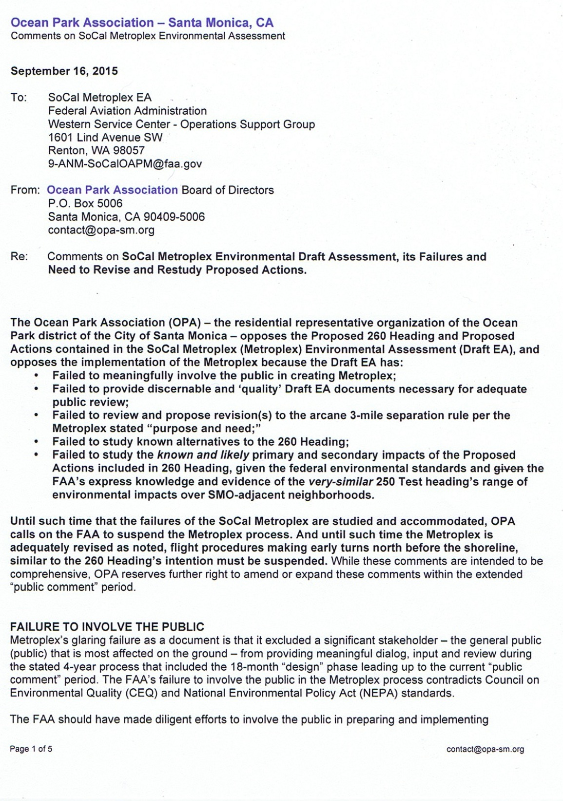
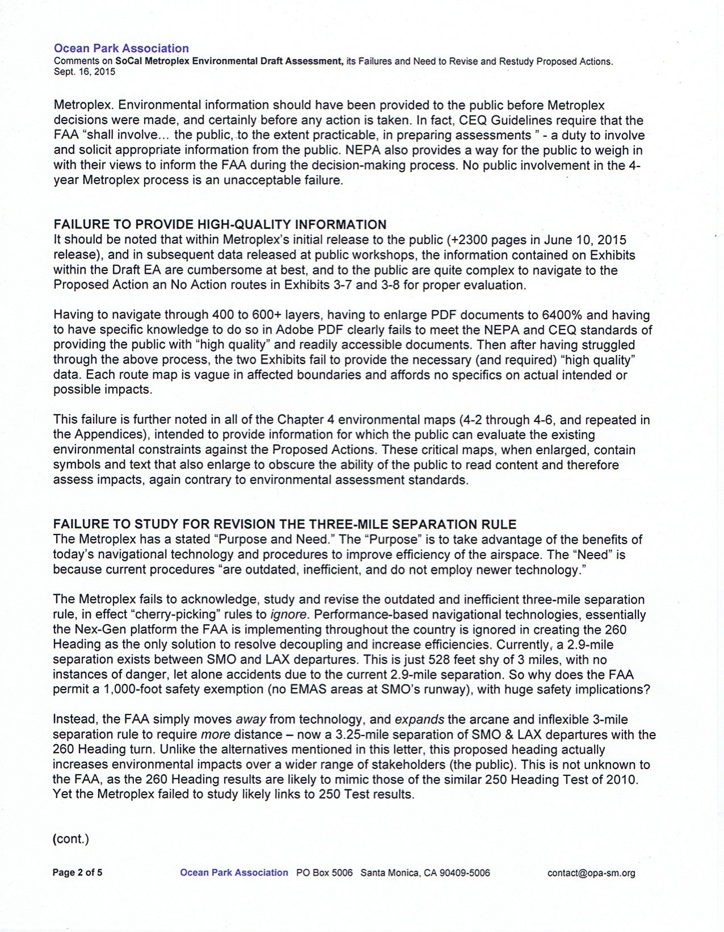
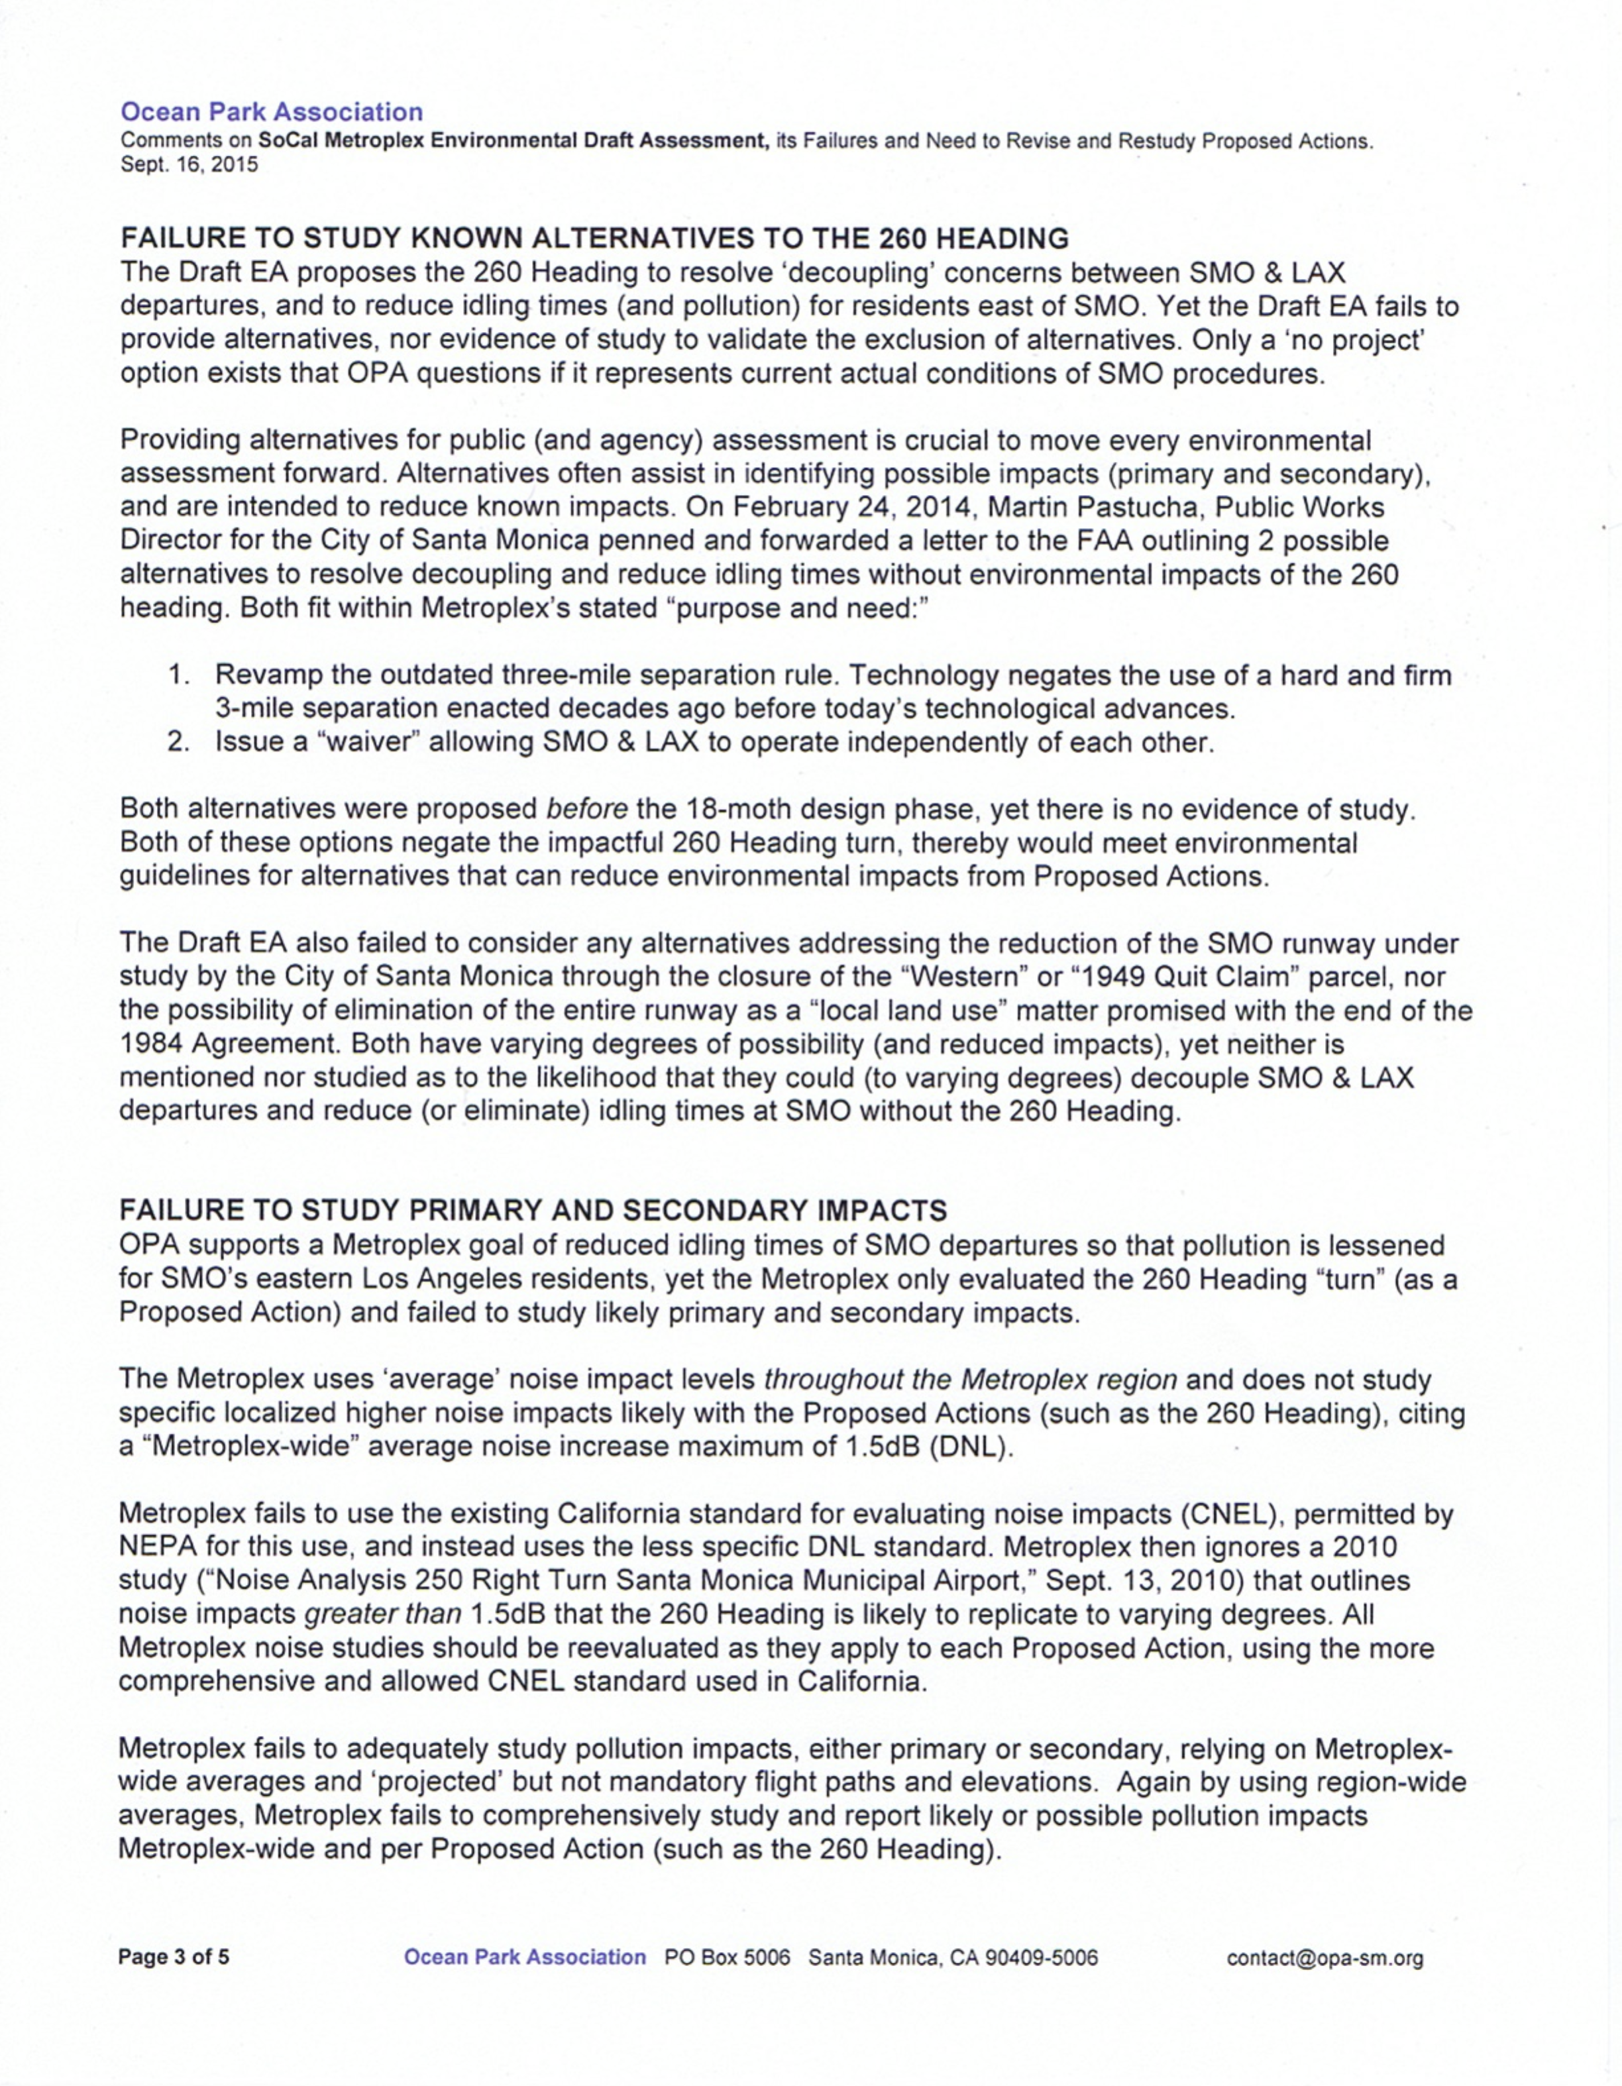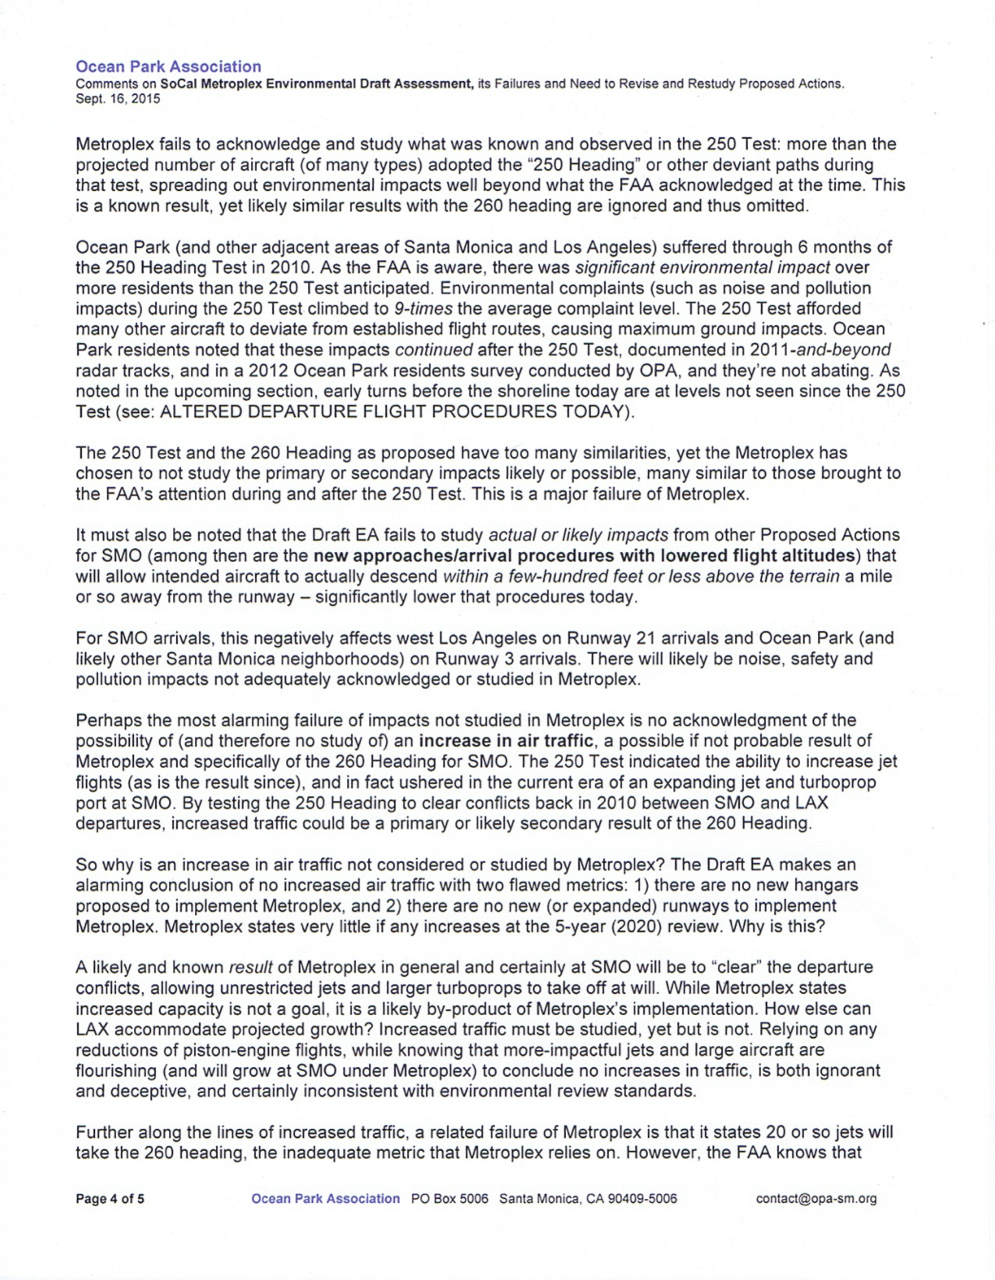

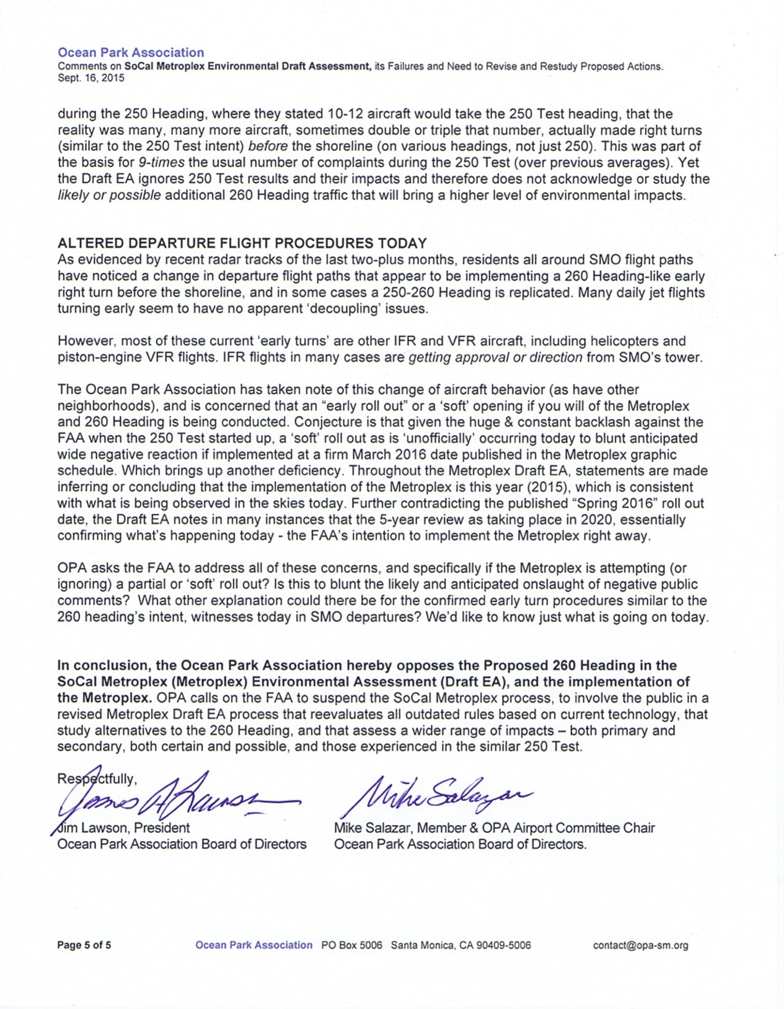

OPA Board Voting Roster

Item: Powerbox Decoration

Motion: OPA enthusiastically asks the committee to develop a work plan with Jessica Cusick, including next steps for gradual implementation and a process to determine the designs and address possible neighbor concerns.

Made by: Judy Seconded by: Mike

Date: 9/14/15

Board Member | Y | N | Abstain |  | Board Member | Y | N | Abstain
Judy Abdo | X |  |  |  | Mary Marlow |  |  | X
David Auch |  | X |  |  | Evan Meyer | X
Andrew Gledhill |  |  |  |  | Marc Morgenstern | X
Patty Godon-Tann |  |  | X |  | Mike Salazar | X
Mark Gorman | X |  |  |  | Jodi Summers | X
Sadat Huq | X |  |  |  | Roger Swanson | X
Kate Kennedy | X |  |  |  | David Tann |  |  | X
Jim Lawson | X

Totals: Yes 10 No 1 Abstain 3 Absent 1

